HRMS ISSUES AND SOLUTION

1. Whenever a user has been assign right on crm and still has issues in viewing hrms establishment post level.

Solution: on CRM always ensure you edit the user and tag the personnel name to the name she was employed as in the system

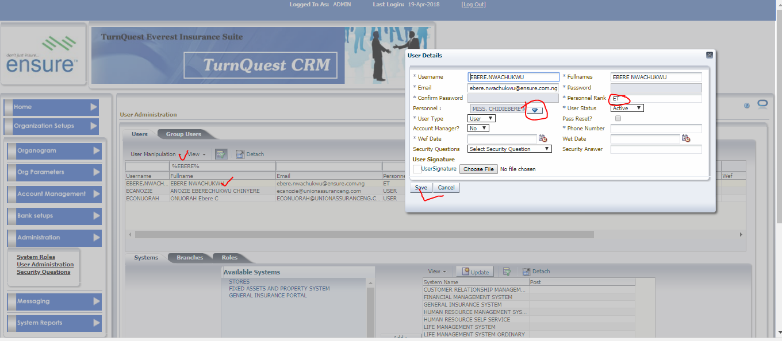

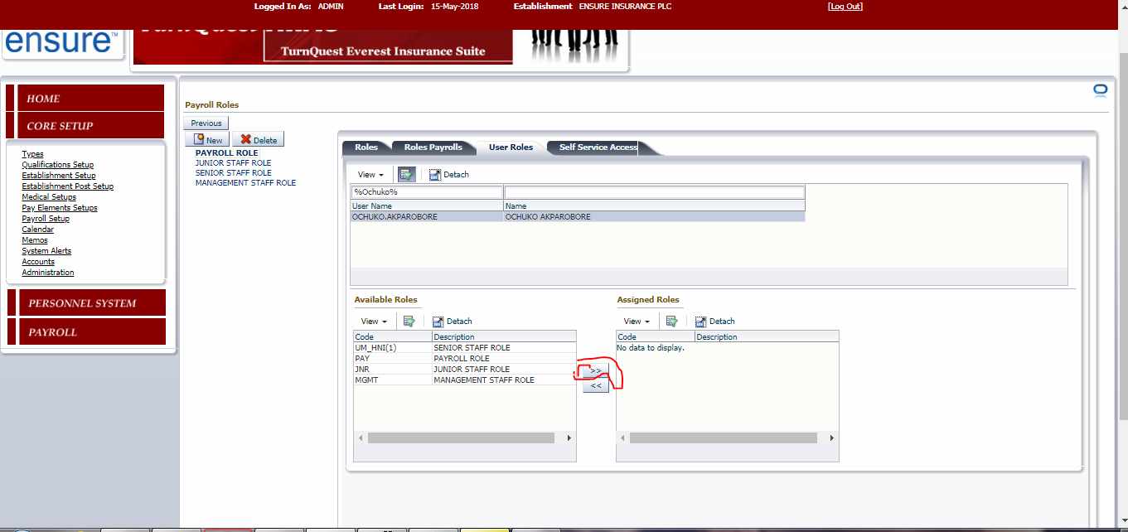

1. issue on personnel missing from some of the client's payroll reports. What was happening there is that, at Post creation, wrong Branches are tagged because the system does not validate the category tagged (Life/Non-Life).

SOLUTION:

Sorting that issue go in forward, ensure that the branches are tagged correctly and then validate the category the personnel falls in

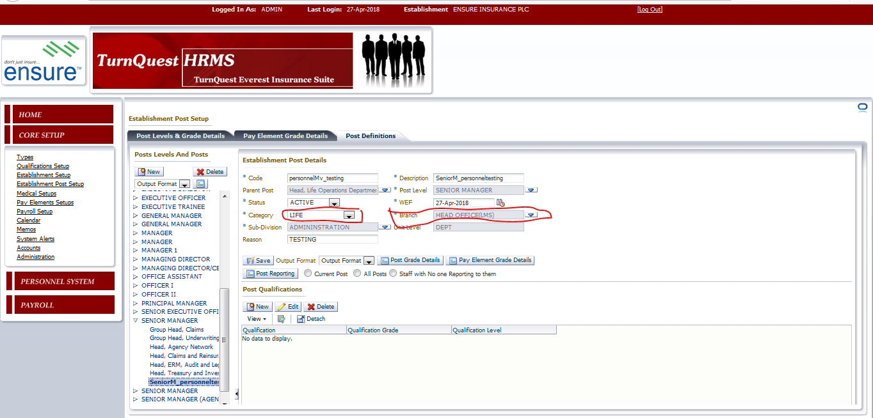

Take for example” this personnel is supposed to be Non life“.once you change the category, the system automatically refreshes the branches.when a user picks category "Life", the system will only spool Life organization branches, and vice versa when category selected is "Non-Life”

